**NAME: E.G.PRADEEP**

**ROLL NO: RA2211004050026**

**SUB: COMMUNICATION LABORATORY**

**ASSIGNMENT-1**

**MATLAB Problem**

1. **Sin Function**
2. **Step function**
3. **Ramp function**
4. **Exponential (growing and decaying)**
5. **Impulse function Solution:**

**Code:**

clc; clear; close all;

%% Time definitions

t = -5:0.01:5; % Continuous time n = -5:1:5; % Discrete time

%%

**1.SINE FUNCTION**

f = 1; % Frequency (Hz) sin_t = sin(2*pi*f*t); sin_n = sin(2*pi*f*n);

figure; subplot(2,1,1);

plot(t, sin_t, 'b', 'LineWidth', 1.5);

title('Continuous Sine Function'); xlabel('t'); ylabel('sin(2\pi f t)'); grid on;

subplot(2,1,2);

stem(n, sin_n, 'r', 'filled');

title('Discrete Sine Function'); xlabel('n'); ylabel('sin(2\pi f n)'); grid on;

%%

**2.STEPFUNCTION:** step_t = t >= 0; step_n = n >= 0;

figure; subplot(2,1,1);

plot(t, step_t, 'b', 'LineWidth', 1.5);

title('Continuous Step Function'); xlabel('t'); ylabel('u(t)'); grid on;

subplot(2,1,2);

stem(n, step_n, 'r', 'filled');

title('Discrete Step Function'); xlabel('n'); ylabel('u[n]'); grid on;

%%

**3.RampFunction** ramp_t = t .* (t >= 0); ramp_n = n .* (n >= 0);

figure; subplot(2,1,1);

plot(t, ramp_t, 'b', 'LineWidth', 1.5);

title('Continuous Ramp Function'); xlabel('t'); ylabel('t u(t)'); grid on;

subplot(2,1,2);

stem(n, ramp_n, 'r', 'filled');

title('Discrete Ramp Function'); xlabel('n'); ylabel('n u[n]'); grid on;

%%

**4.Exponentional Function** exp_grow_t = exp(0.5*t); exp_decay_t = exp(-0.5*t); exp_grow_n = exp(0.5*n); exp_decay_n = exp(-0.5*n);

figure; subplot(2,2,1);

plot(t, exp_grow_t, 'b', 'LineWidth', 1.5);

title('Continuous Growing Exponential'); xlabel('t'); ylabel('e^{0.5t}'); grid on;

subplot(2,2,2);

plot(t, exp_decay_t, 'r', 'LineWidth', 1.5);

title('Continuous Decaying Exponential'); xlabel('t'); ylabel('e^{-0.5t}'); grid on;

subplot(2,2,3);

stem(n, exp_grow_n, 'b', 'filled');

title('Discrete Growing Exponential'); xlabel('n'); ylabel('e^{0.5n}'); grid on;

subplot(2,2,4);

stem(n, exp_decay_n, 'r', 'filled');

title('Discrete Decaying Exponential'); xlabel('n'); ylabel('e^{-0.5n}'); grid on;

%%

**5.Impulse Function** impulse_t = (t == 0); impulse_n = (n == 0);

figure; subplot(2,1,1);

plot(t, impulse_t, 'b', 'LineWidth', 1.5);

title('Continuous Impulse Function (Ideal)'); xlabel('t'); ylabel('\delta(t)'); grid on;

subplot(2,1,2);

stem(n, impulse_n, 'r', 'filled');

title('Discrete Impulse Function'); xlabel('n'); ylabel('\delta[n]'); grid on;

Graph

Sin Function

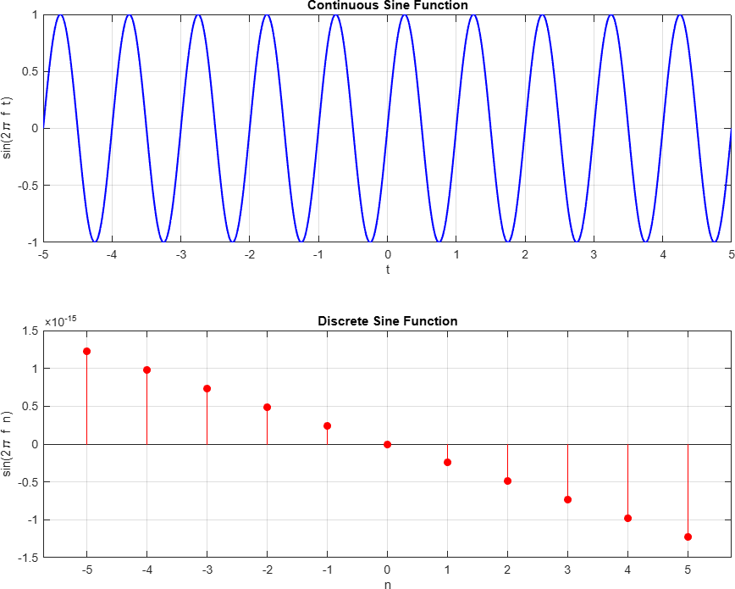

Step Function

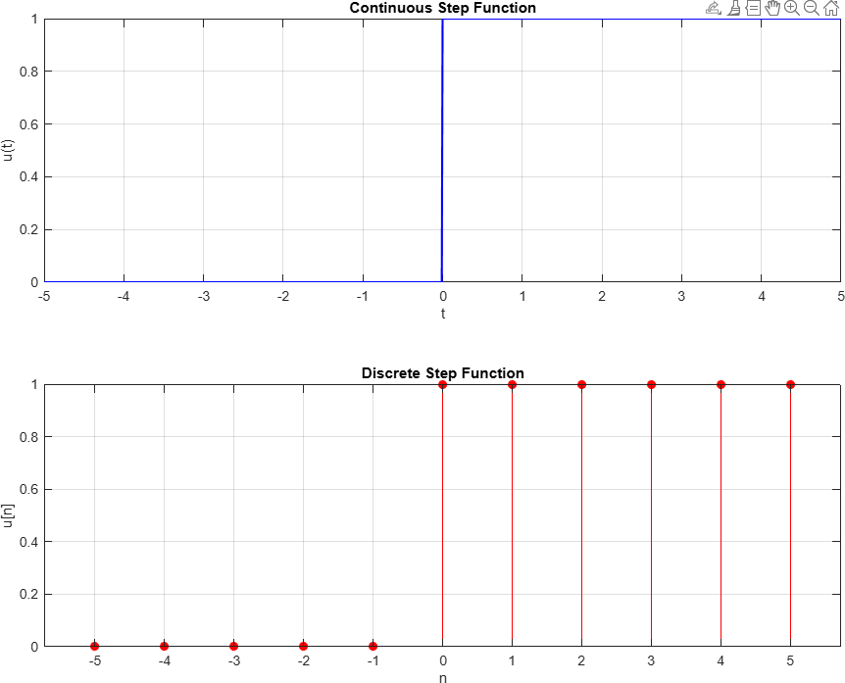

Ramp Function

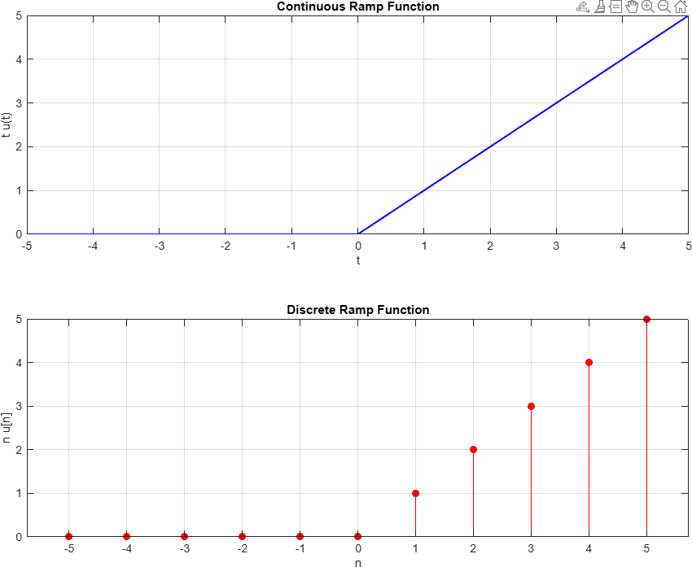

Exponential

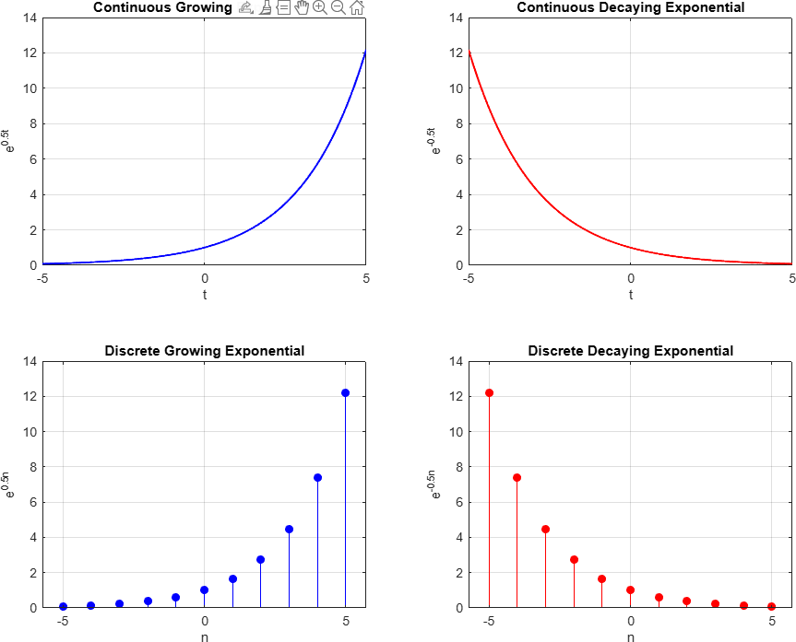

Impulse Function

